Consider all the leaves of a binary tree.  From left to right order, the values of those leaves form a *leaf value sequence.*

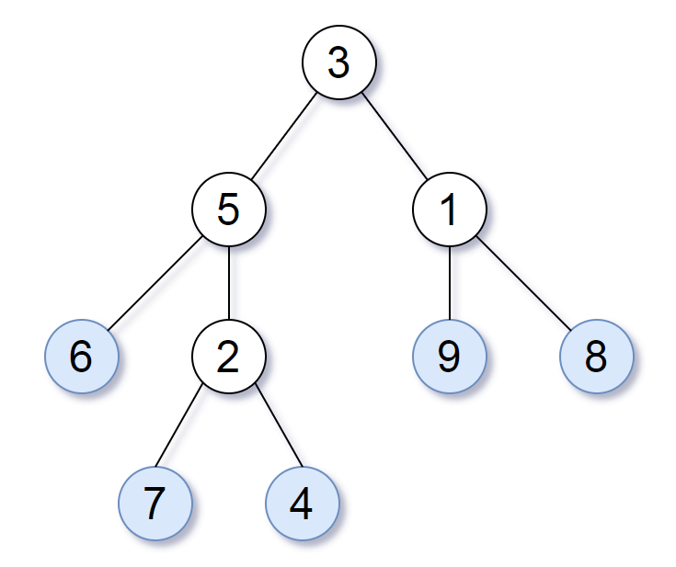

For example, in the given tree above, the leaf value sequence is (6, 7, 4, 9, 8).

Two binary trees are considered *leaf-similar* if their leaf value sequence is the same.

Return true if and only if the two given trees with head nodes root1 and root2 are leaf-similar.

**Constraints:**

* Both of the given trees will have between 1 and 200 nodes.
* Both of the given trees will have values between 0 and 200